Tema 1:

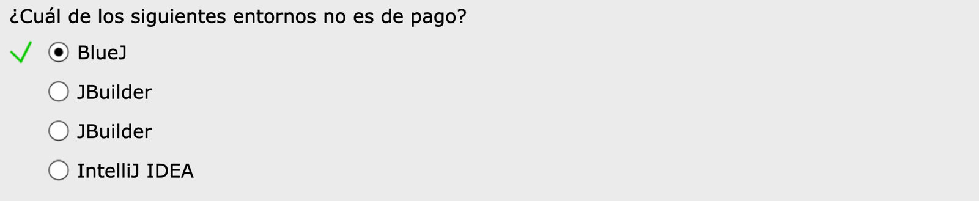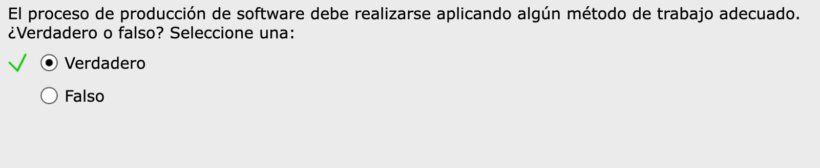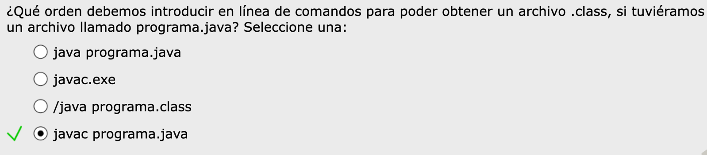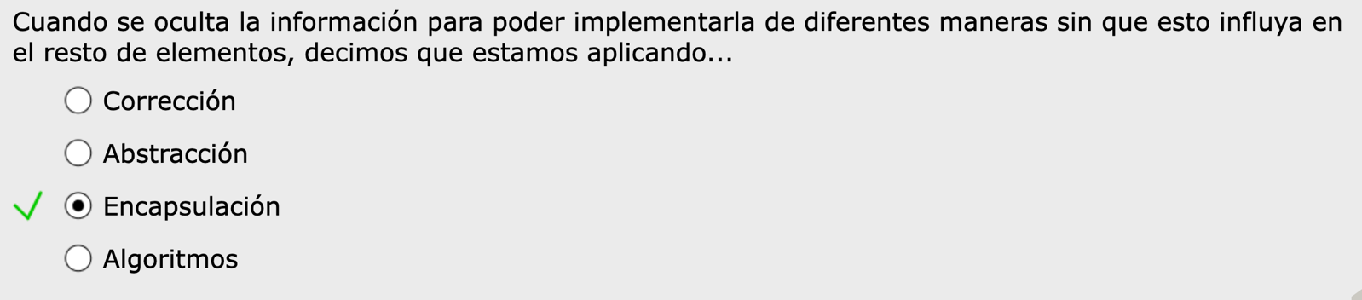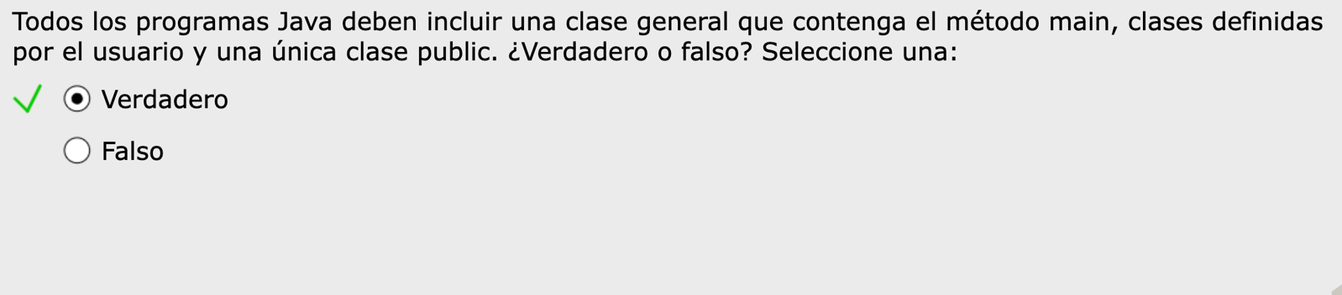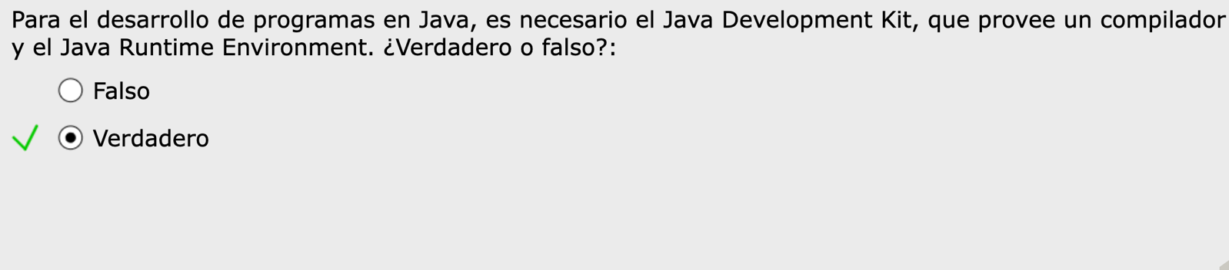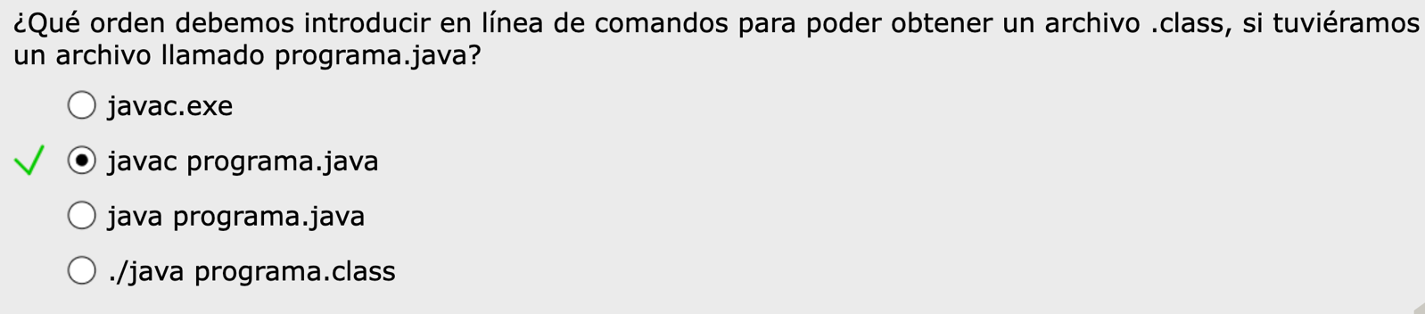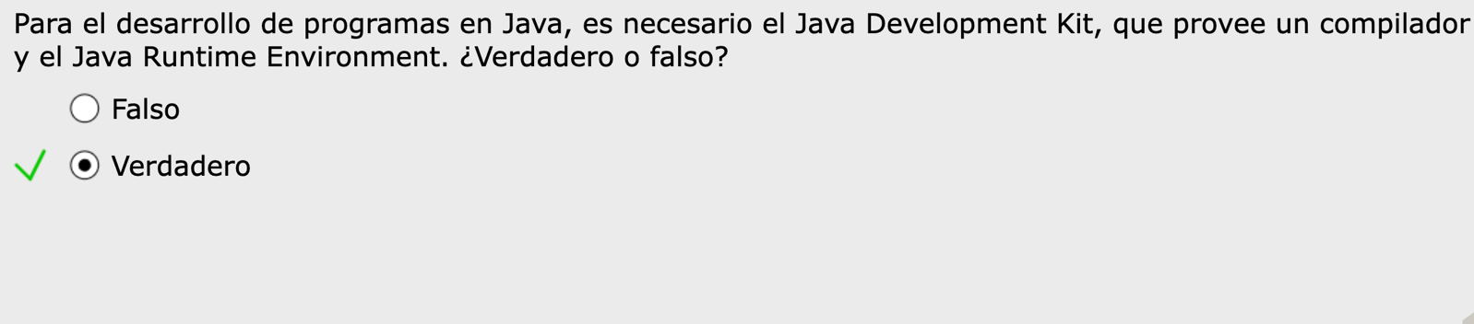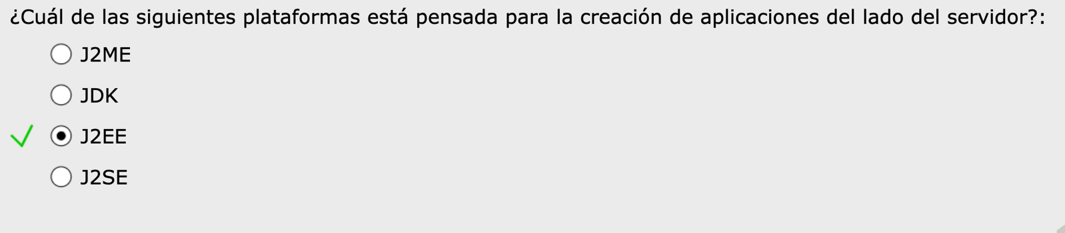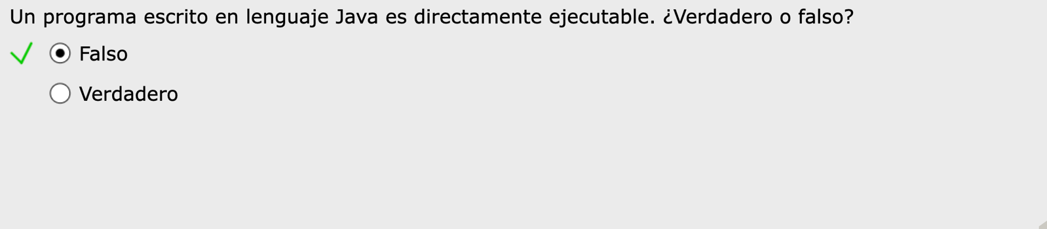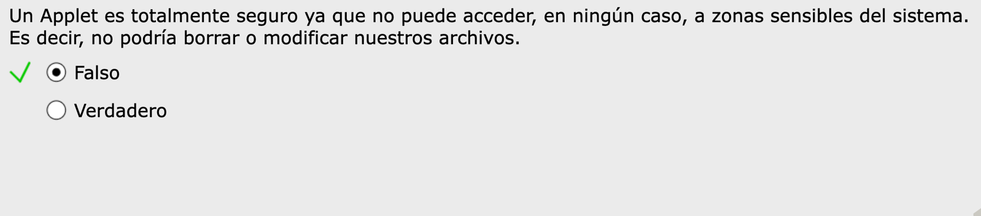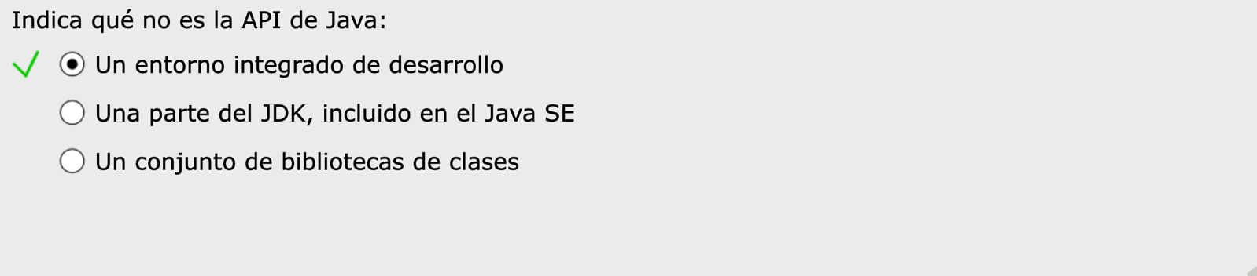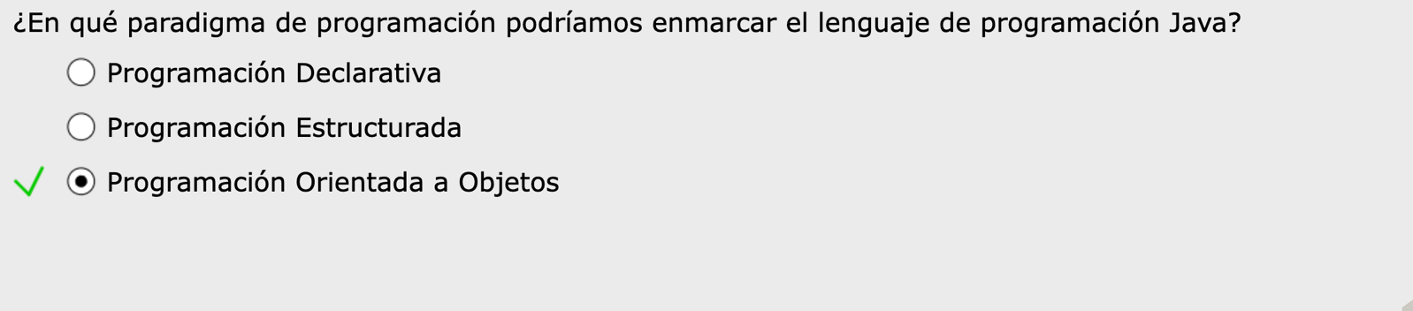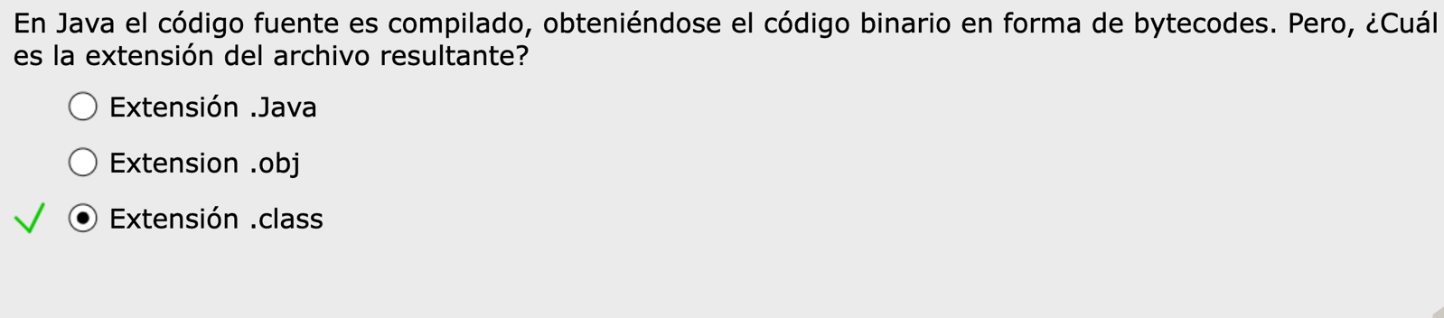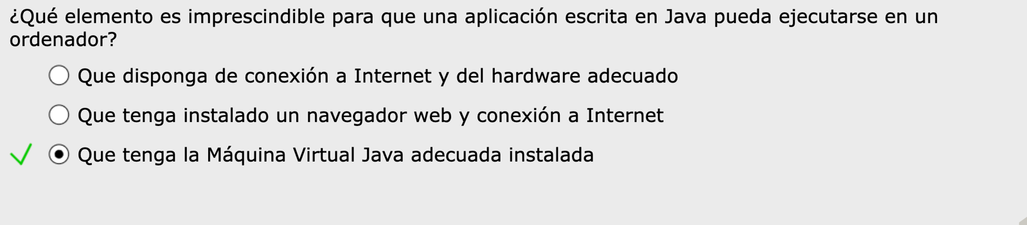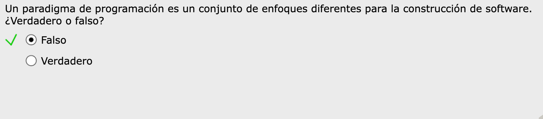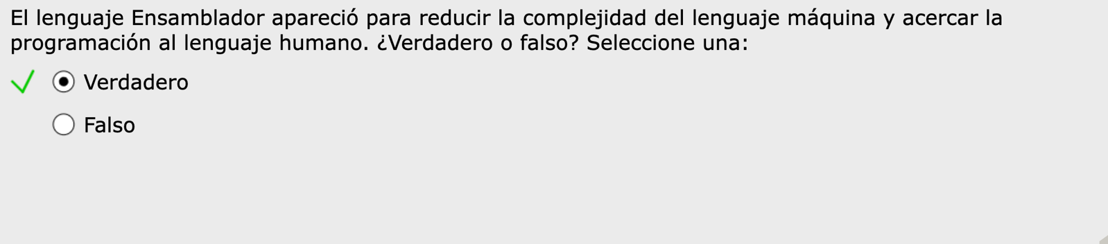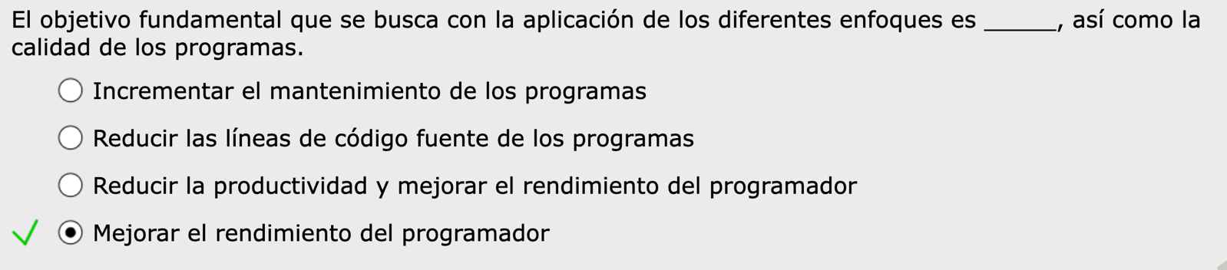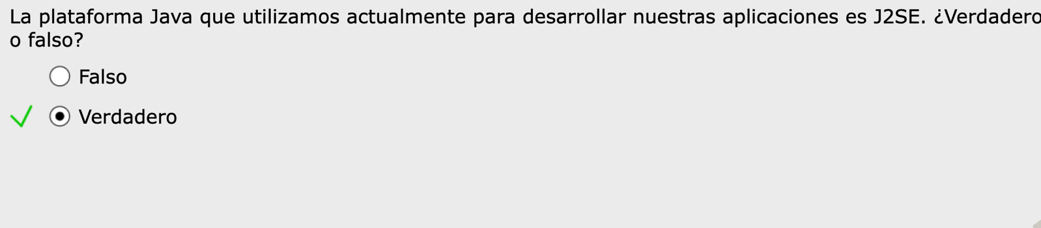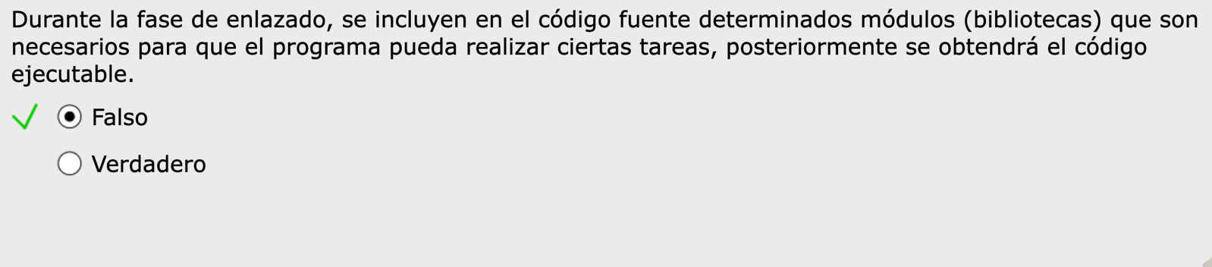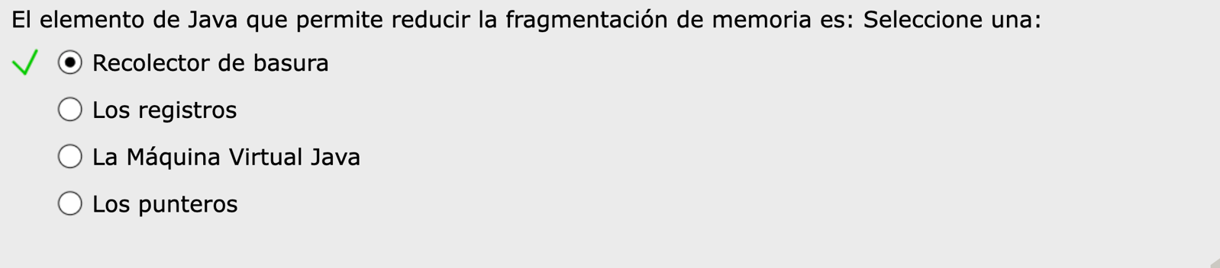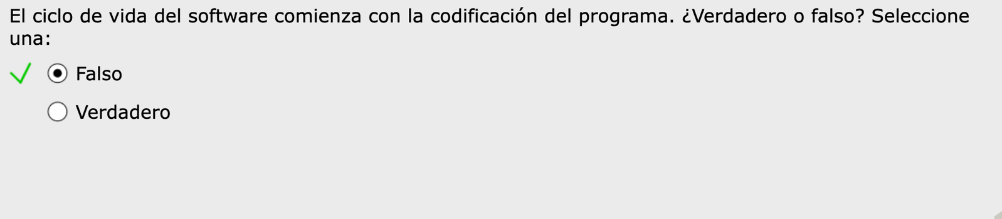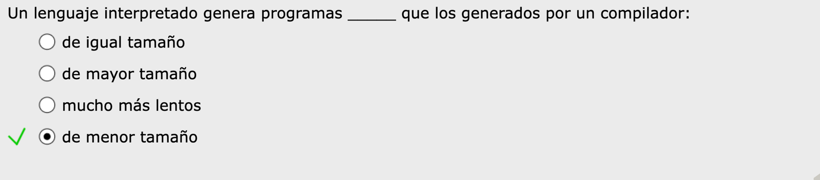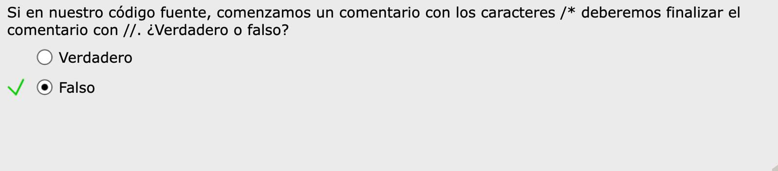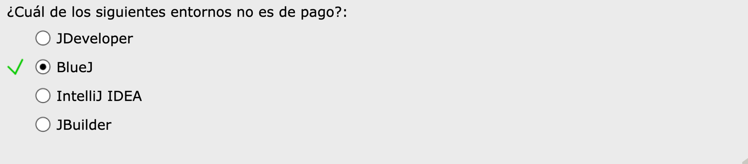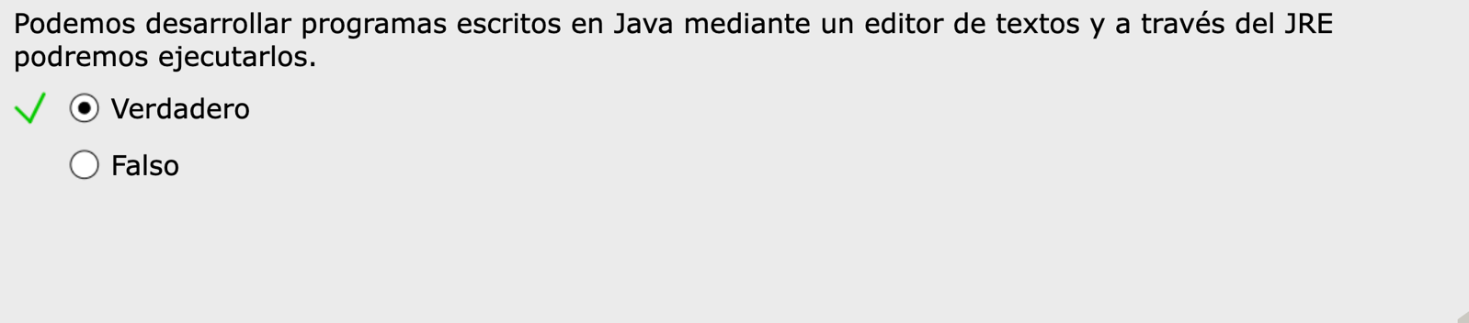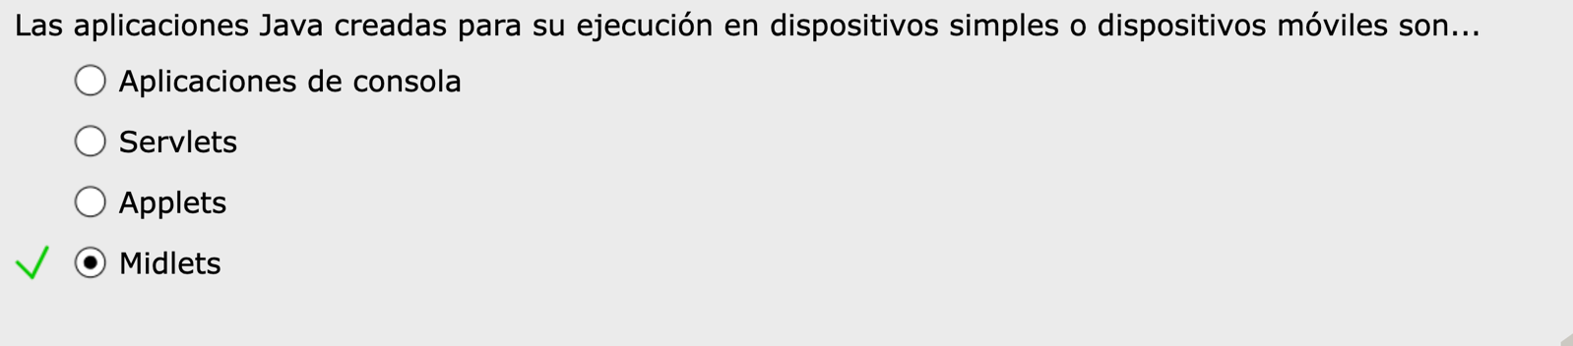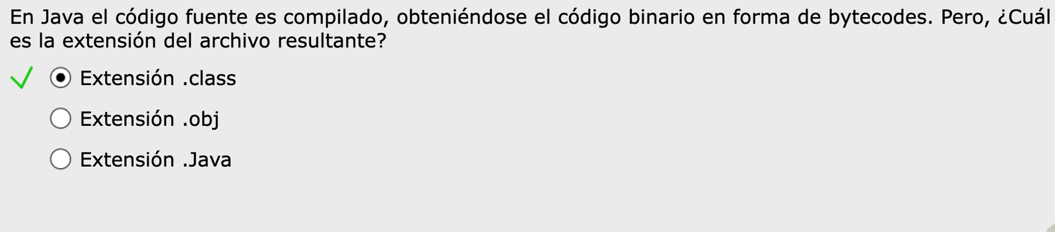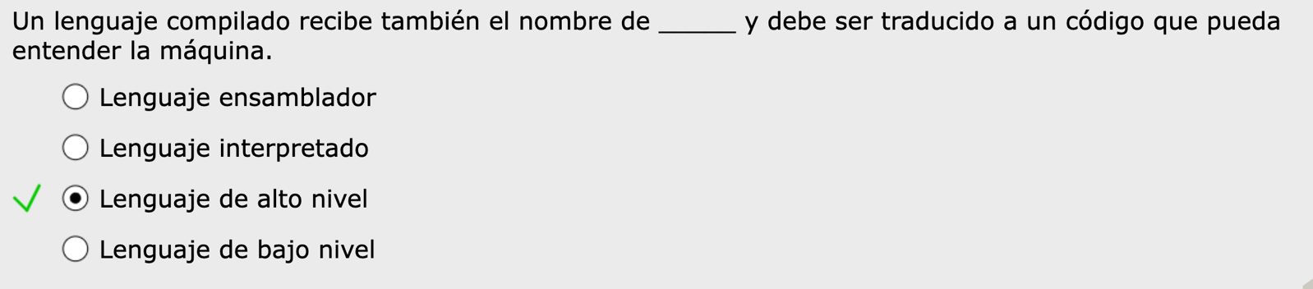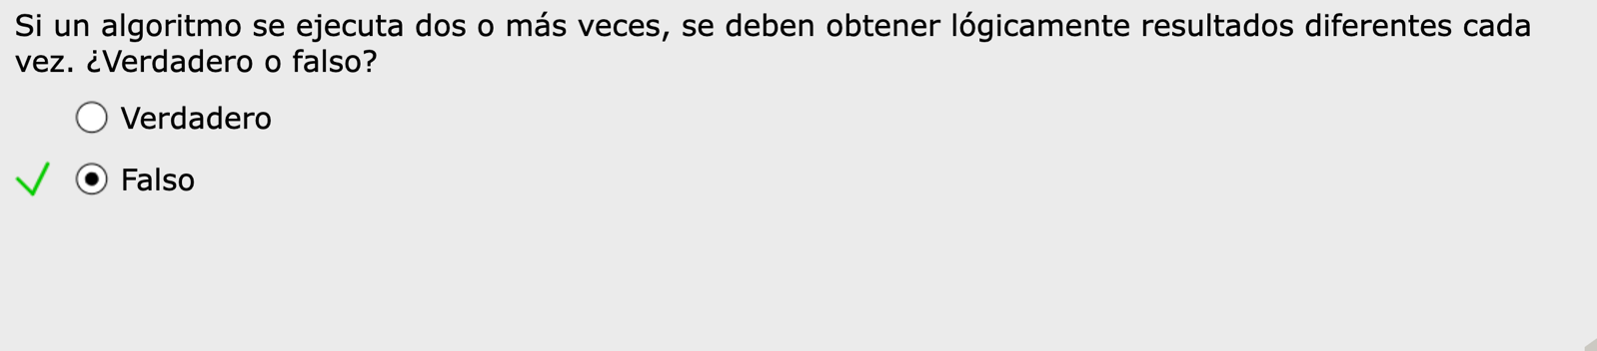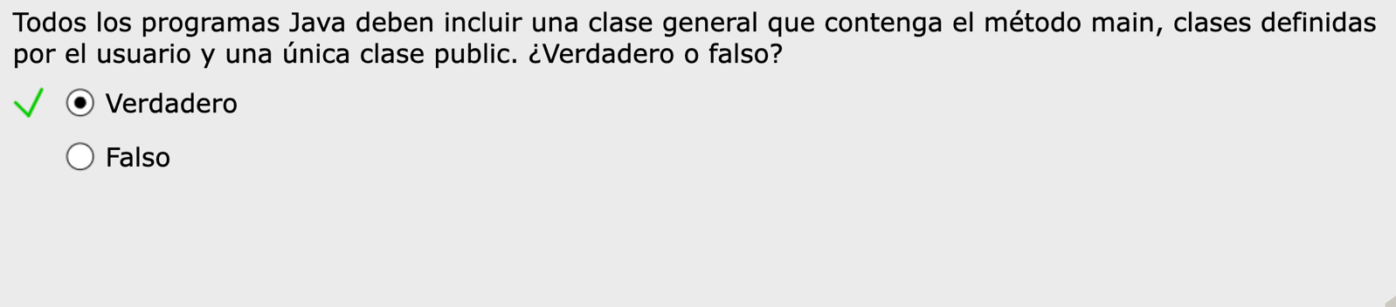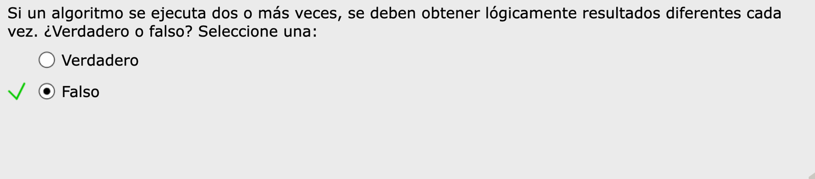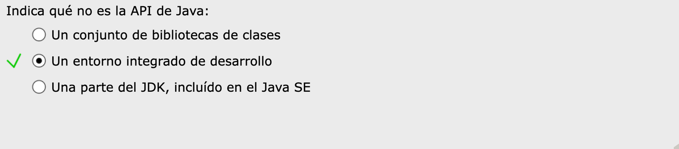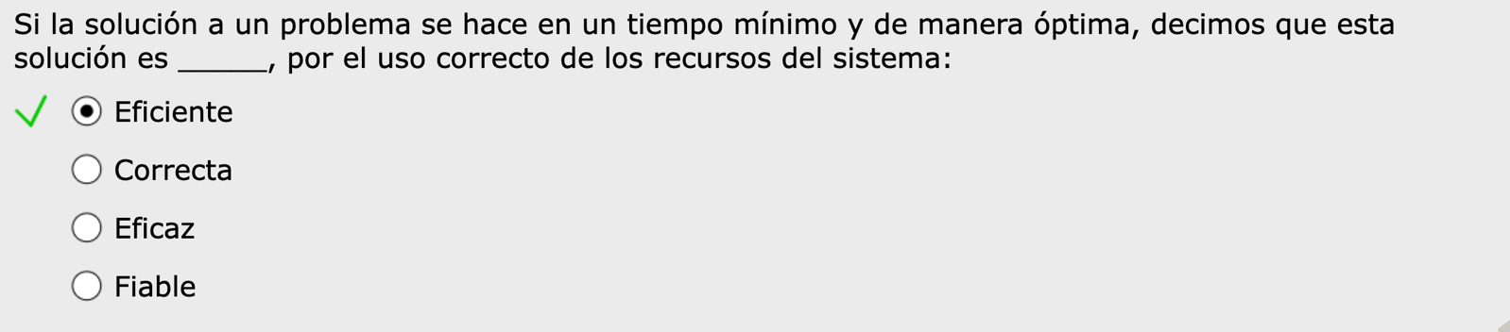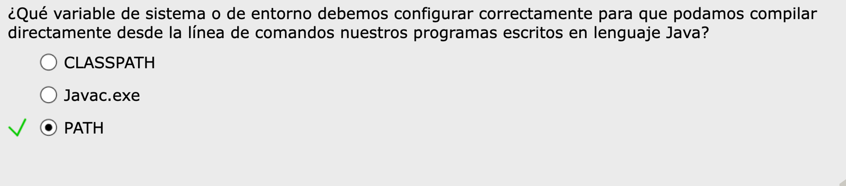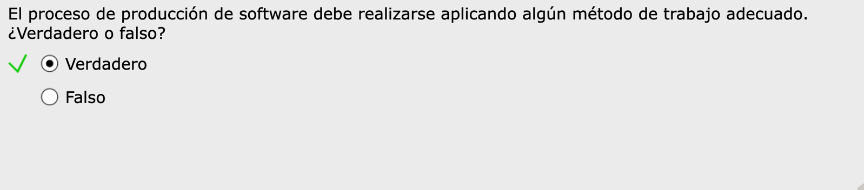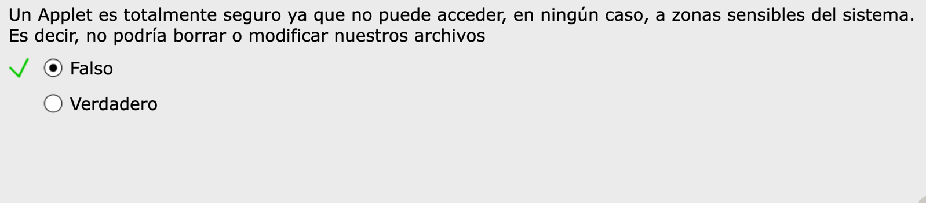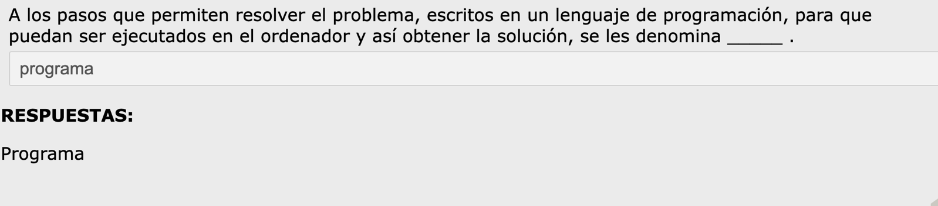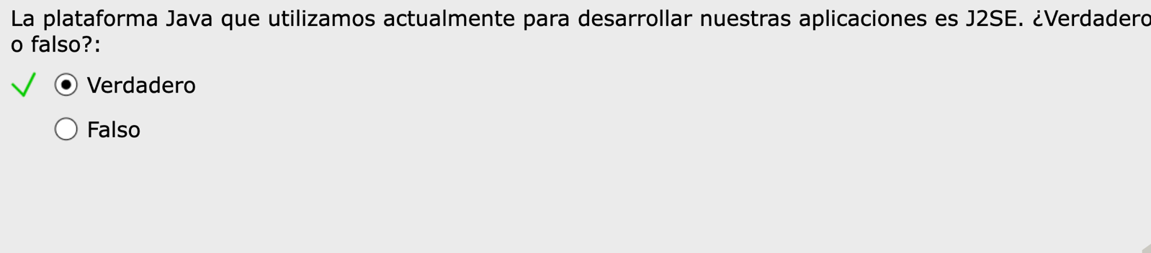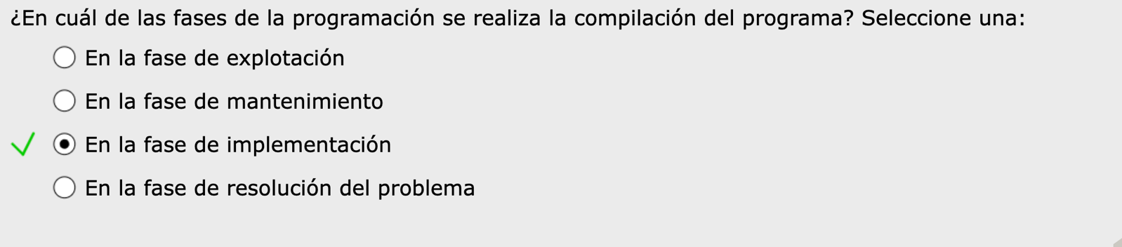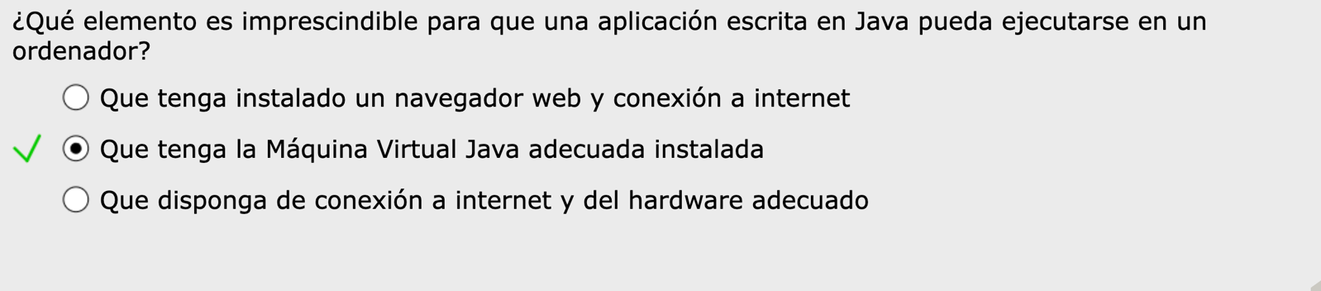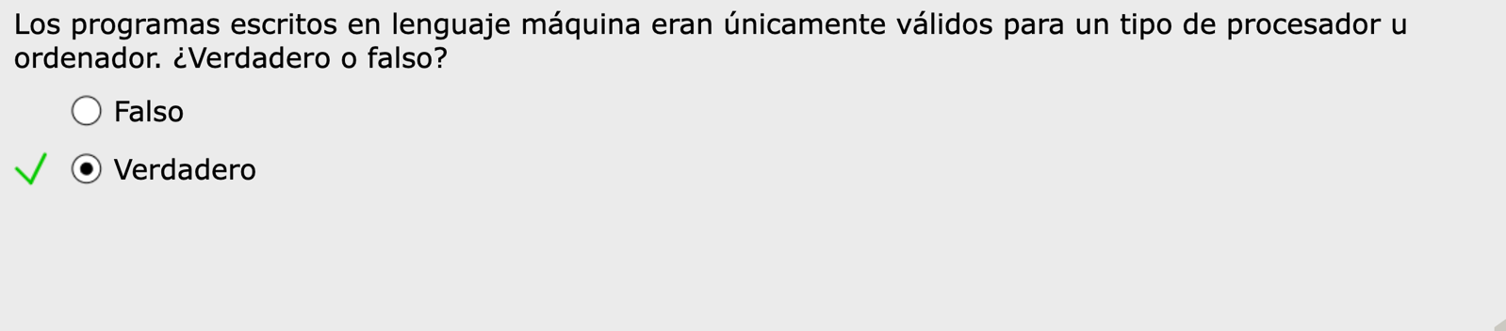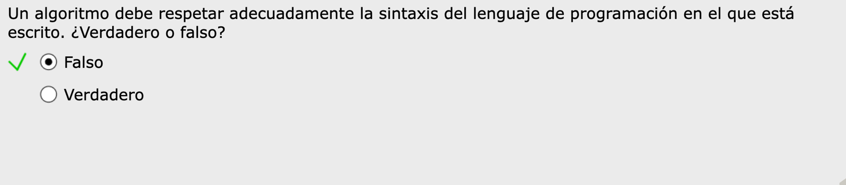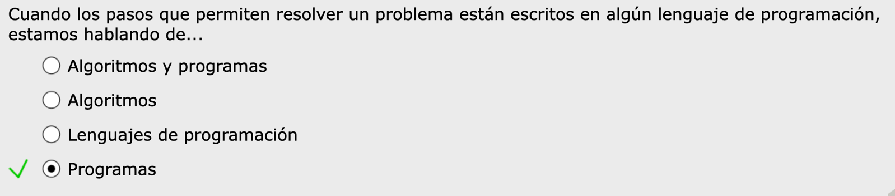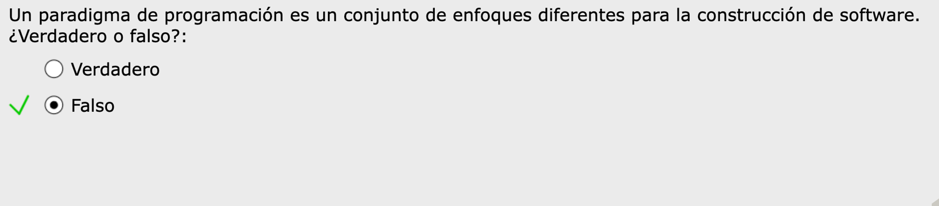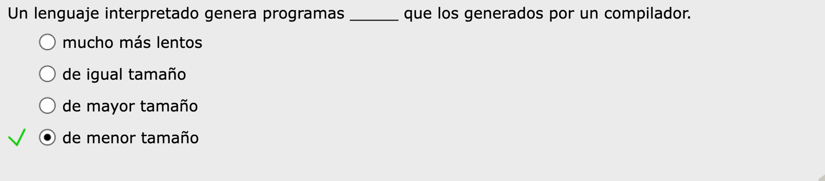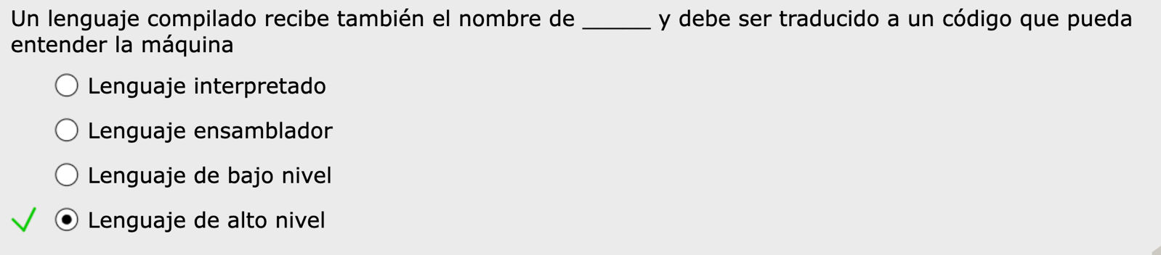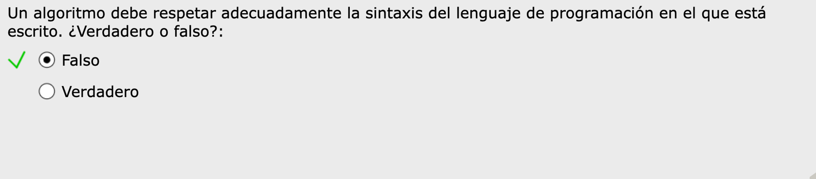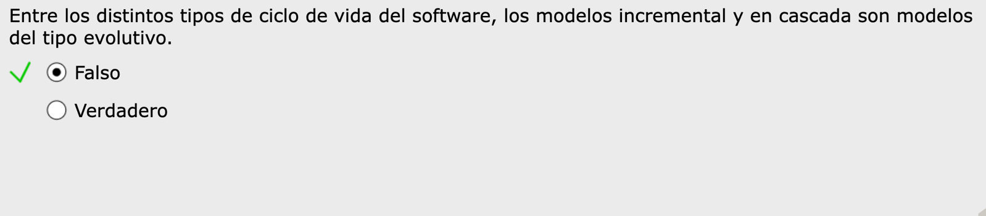

<https://www.daypo.com/programacion-dam-tema-1.html#test>